**ASSIGNMENT 17.2**

Dataset Link: **https://drive.google.com/file/d/0B_P3pWagdIrrQnAxZHZKcmxBQW8/view**

PROBLEM STATEMENT 1:

1) Read the text file, and create a tupled rdd.

Solution:

We have read the text file from the above dataset link given and then created a tuple rdd.



2) Find the count of total number of rows present.

Solution:



3) What is the distinct number of subjects present in the entire school.

Solution:

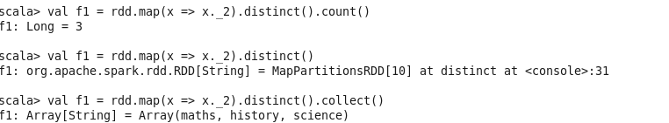

4) What is the count of the number of students in the school, whose name is Mathew and marks, is 55

Solution:

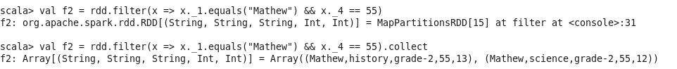

PROBLEM STATEMENT 2

1) What is the count of students per grade in the school?

Solution:

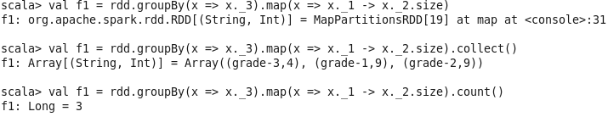

2) Find the average of each student (Note - Mathew is grade-1, is different from Mathew in some other grade!)

Solution:

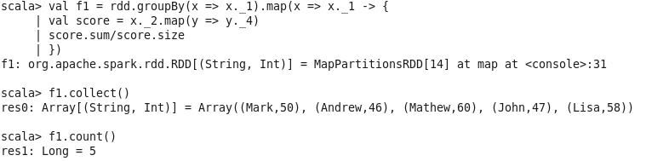

3) What is the average score of students in each subject across all grades?

Solutions:

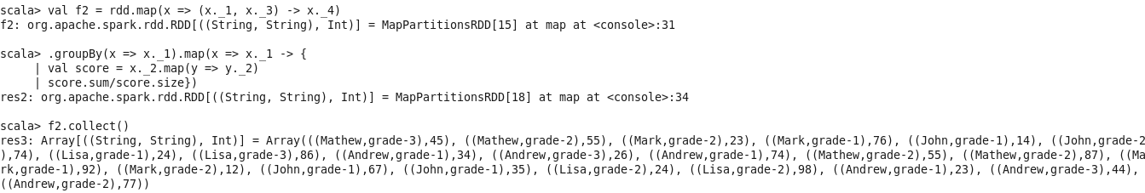

4) What is the average score of students in each subject per grade?

Solutions:

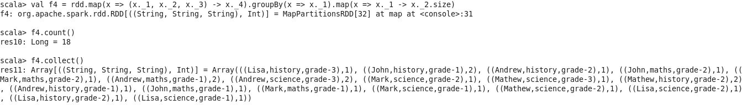

5) For all students in grade-2, how many have average score greater than 50?

Solutions:

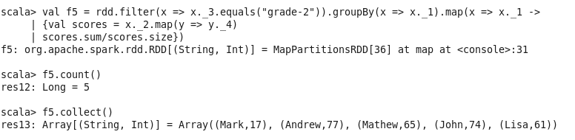

PROBLEM STATEMENT 3:

Are there any students in the college that satisfy the below criteria :

1. Average score per student_name across all grades is same as average score per student_name per grade

Solutions:

